ONEWAY CRT BY DAW
/STATISTICS DESCRIPTIVES HOMOGENEITY WELCH
/PLOT MEANS
/MISSING ANALYSIS.

Oneway

Notes
Output Created |  | 05-May-2019 23:23:21
Comments
Input | Active Dataset | DataSet0
Input | Filter | <none>
Input | Weight | <none>
Input | Split File | <none>
Input | N of Rows in Working Data File | 30
Missing Value Handling | Definition of Missing | User-defined missing values are treated as missing.
Missing Value Handling | Cases Used | Statistics for each analysis are based on cases with no missing data for any variable in the analysis.
Syntax |  | ONEWAY CRT BY DAW  /STATISTICS DESCRIPTIVES HOMOGENEITY WELCH  /PLOT MEANS  /MISSING ANALYSIS.
Resources | Processor Time | 00 00:00:00.172
Resources | Elapsed Time | 00 00:00:00.172

[DataSet0]

Descriptives
 | N | Mean | Std. Deviation | Std. Error | 95% Confidence Interval for Mean
 |  |  |  |  | Lower Bound | Upper Bound
1-3 days a week | 12 | 7.4167 | 3.21526 | .92816 | 5.3738 | 9.4595
3-5 days a week | 5 | 9.0600 | 3.39382 | 1.51776 | 4.8460 | 13.2740
5-7 days a week | 13 | 9.6000 | 3.28634 | .91147 | 7.6141 | 11.5859
Total | 30 | 8.6367 | 3.32291 | .60668 | 7.3959 | 9.8775

Descriptives
 | Minimum | Maximum
1-3 days a week | 3.20 | 12.20
3-5 days a week | 4.50 | 14.00
5-7 days a week | 4.40 | 13.60
Total | 3.20 | 14.00

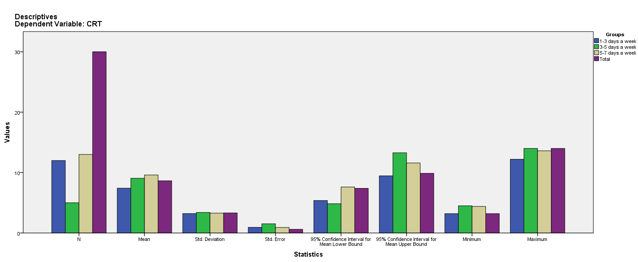

Test of Homogeneity of Variances
CRT
Levene Statistic | df1 | df2 | Sig.
.612 | 2 | 27 | .550

ANOVA
CRT
 | Sum of Squares | df | Mean Square | F | Sig.
Between Groups | 30.821 | 2 | 15.411 | 1.438 | .255
Within Groups | 289.389 | 27 | 10.718
Total | 320.210 | 29

Robust Tests of Equality of Means
CRT
 | Statisticª | df1 | df2 | Sig.
Welch | 1.379 | 2 | 11.268 | .291
a. Asymptotically F distributed.

Means Plots

